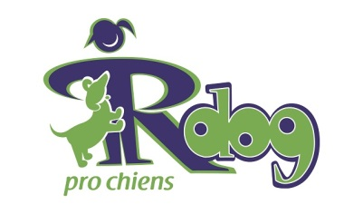

**Sample Media Alert**

(Can include your club logo, RDOG logo and fun graphics)

A NOTE FROM YOUR BEST FRIEND:  
IT’S RDOG DAY! MEET ME AT (YOUR VENUE)

Each year at this time, the Canadian Kennel Club, along with affiliated clubs and other organizations across the country participate in Responsible Dog Ownership (RDOG) events in their local communities. It’s an opportunity to educate the public about the responsibilities of dog ownership and have fun with our family, friends and pets.

This year **(Your Club/Group)** is excited to present an RDOG Day celebration like no other!

**(Sample Feature Events)** Agility, Obedience and Rally Demonstrations, Retriever Trials, Canine Good Neighbour Testing, Dog Grooming Demonstrations, Microchip Clinic, Doggie Loot Bags, Music. Entertainment for Kids, Face Painting, Great Food and Fun for the Whole Family, Etc.

WHO: **(Your Group/Club)** and the Canadian Kennel Club team up to present National RDOG Day Celebrations.

WHAT: A fun-filled, free event for anyone and everyone who loves dogs.

• Your Feature Event 1

• Your Feature Event 2

• Your Feature Event 3

• Your Feature Event 4

• Your Feature Event 5

WHERE: Your Venue

WHEN: Date and time

MEDIA CONTACTS: Your Name(s), Phone Number(s) Web and Email Addresses