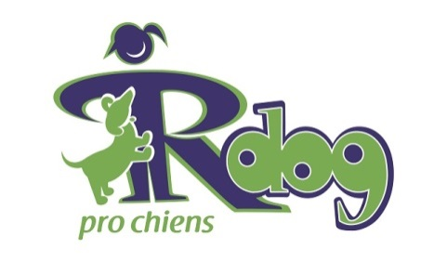

**Email Blast Sample**

Subject: Every RDOG has its Day - This year it’s September 00!

Heading:  
You’re Invited to Celebrate National RDOG Day  
with [local club or organization] and the Canadian Kennel Club.  
Bring Your Family! Bring Your Friends!  
Bring the Dog!

Subhead: Saturday September 00 at [location] from 00am to 00pm.

Enjoy (list of featured events) plus food, fun and excitement for the entire family…including the dog!

Click here for all the details **<link to your web page>**

Subtext:  
Responsible Dog Ownership (RDOG) Day is a national celebration of the devotion, loyalty and friendship that the dogs in our communities offer us. It is an initiative of the Canadian Kennel Club and supported by like-minded organizations and individuals across Canada.

Learn more about RDOG Day at [www.ckc.ca](http://www.ckc.ca)