October 2, 2024

Jeff Cornett

Executive Director

Canadian Kennel Club

Via email: jcornett@ckc.ca

Sheila Goffe

Vice President, Government Relations

American Kennel Club

Via email: Sheila.Goffe@akc.org

Dear Jeff Cornett and Sheila Goffe,

Thank you for your letter to Centers for Disease Control and Prevention (CDC) Director Mandy K. Cohen, MD, MPH. I am responding on behalf of Dr. Cohen.

We understand the concerns and sensitivities around this issue. Dogs are closely intertwined with our lives, providing millions of Americans companionship, support, and service. Protecting American communities and dogs from the importation of rabies—a disease that is virtually 100% fatal to people and dogs without a vaccine—is a key goal of these new dog importation rules. Rabies kills more than 59,000 people a year globally (40% of them children). Dog rabies is found in more than 100 countries. Further, CDC has seen numerous instances of falsified and inaccurate vaccination records from animals imported from high-risk countries. In recent years, CDC has documented cases of rabid dogs from high-risk countries having entered the United States, including one through a rabies low-risk/rabies-free country, exposing dozens of people and animals to this lethal disease and triggering major, multi-state public health responses. Additionally, there are numerous instances of importers trying to import dogs from high-risk countries through low-risk countries without adequate rabies vaccination. Every importation of dog rabies risks potentially re-introducing the deadly virus into pets, wildlife, and people in the United States. The U.S. eliminated dog rabies in 2007 after millions of dollars and decades of effort.

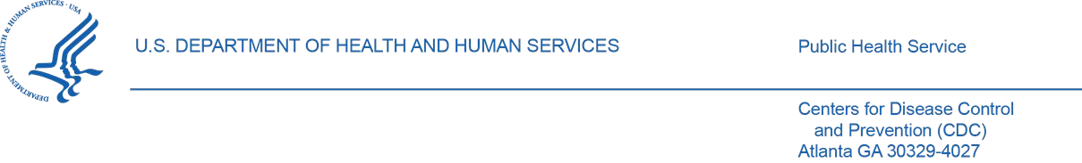

CDC’s modernized dog importation rule aims to better protect people and animals from the importation of rabies while ensuring that dog owners and importers are not unnecessarily overburdened. Your letter and the input from other members of the public and organizations have helped CDC strike that balance more effectively, and we are grateful for that input. We want to share some key parts of the new rule and important ways we are making the rule more flexible and less burdensome.

CDC has substantially streamlined and simplified the new rule’s process for the vast majority of people bringing a dog into the United States. If you are bringing a dog that has only been in rabies-free and low-risk countries over the last six months—including Canada, Mexico, the United Kingdom, every European Union country, Japan, and dozens of other countries—you only need to fill out one simple online form (the [*CDC Dog Import F*](https://www.cdc.gov/importation/dogs/dog-import-form-instructions.html)*orm*) for entry. The form takes a few minutes to complete, can be completed before travel or as people wait to enter the United States, and can be shown to airlines and border officials as a printed copy or on an electronic device. People do not need a form from their veterinarian, and the *CDC Dog Import* form receipt, is good for multiple entries for six months from the date of issuance, minimizing the burden on travelers who enter the United States regularly. This flexibility and convenience are designed to make the process as easy as possible for travelers, while still ensuring the safety of our communities and animals.

The rule also requires that all dogs be microchipped and be at least six months of age. These requirements better protect the health of people and animals, by preventing high-risk dogs with falsified or unverified veterinary documentation from entering the United States through rabiesfree and low-risk countries. The six-month age requirement also aligns CDC’s rules with current regulations of the United States Department of Agriculture under the Animal Welfare Act, which requires dogs imported for resale to be at least six months old on arrival.

Every American community and dog owner benefits from the United States being free from dog rabies. As this rule is implemented in the coming weeks and months, we will carefully monitor how it is working on the ground and adjust our approach as needed, as we did with the new streamlined processes described above. This rule provides multiple options for dogs coming from high-risk countries to meet the requirements, while also preventing the arrival of dogs with questionable or inadequate vaccination. CDC has taken an important step forward to protect American communities and animals from the importation of infectious diseases like rabies, and we will improve the rule and how we implement it based on feedback from our partners.

Thank you again for your outreach and commitment to this issue. For more information, please visit our website: [www.cdc.gov/dogtravel.](http://www.cdc.gov/dogtravel)

# Sincerely,

# Daniel Jernigan, MD, MPH

Director, National Center for Emerging and

Zoonotic Infectious Diseases

# CDC